Q1：

**3.**

Putative matches: I selected all pairs of key features whose spatial distance is below the 0.03 * max(spatial distance), here’s the result.

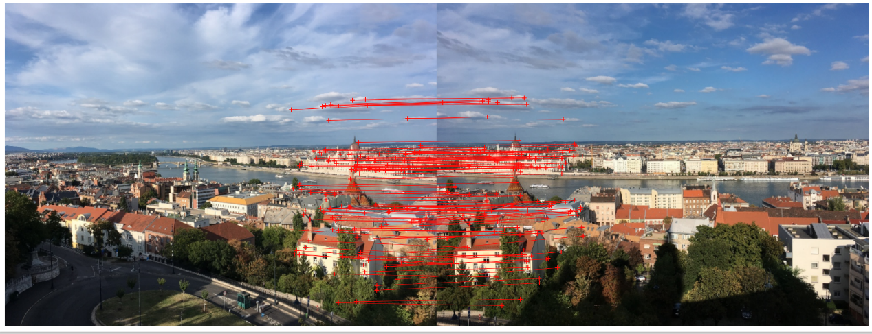

**4.**

The RANSAC algorithm here is used to find the best homography matrix that maps correspondence between two sets of the points.   
The hyperparameters used in this implementation are:

1. distance_threshold: The maximum distance between a correspondence and its projection under the computed homography matrix for it to be considered an inlier. The default value is 2.
2. outlier_ratio: The maximum fraction of correspondences that are allowed to be outliers. The default value is 0.2.
3. p: The probability of finding the correct model given a set of correspondences. The default value is 0.99.
4. s: The size of the random subset of correspondences that is selected for each RANSAC iteration. The default value is 4.
5. e: The maximum fraction of correspondences that are allowed to be outliers. The default value is 0.2.

The algorithm uses a loop that runs for N iterations, where N is calculated based on the values of p, s, and e. At each iteration, s random correspondences are selected from the input data and a homography matrix is computed using those correspondences. The homography matrix is then used to project all the correspondences and the distance between the projected points and the actual points is computed. Correspondences that are within the distance threshold are considered inliers, while the rest are considered outliers. If the number of inliers is greater than the number of inliers found in previous iterations, the homography matrix, inliers, and residuals are updated accordingly. The loop terminates early if the number of outliers is less than the specified outlier ratio.  
 The average residual is 0.753, and the number of inliers is 144.

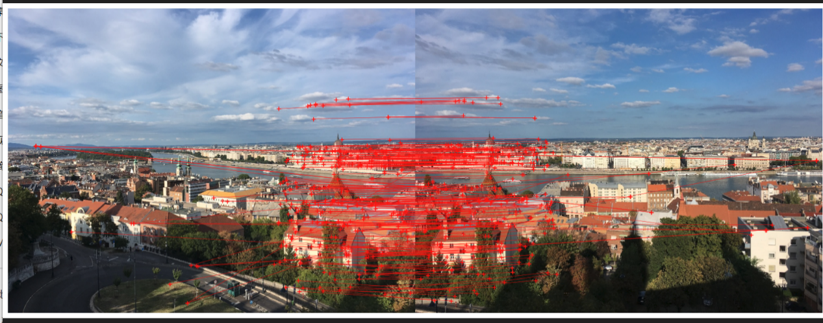

1. This is the stitched image:

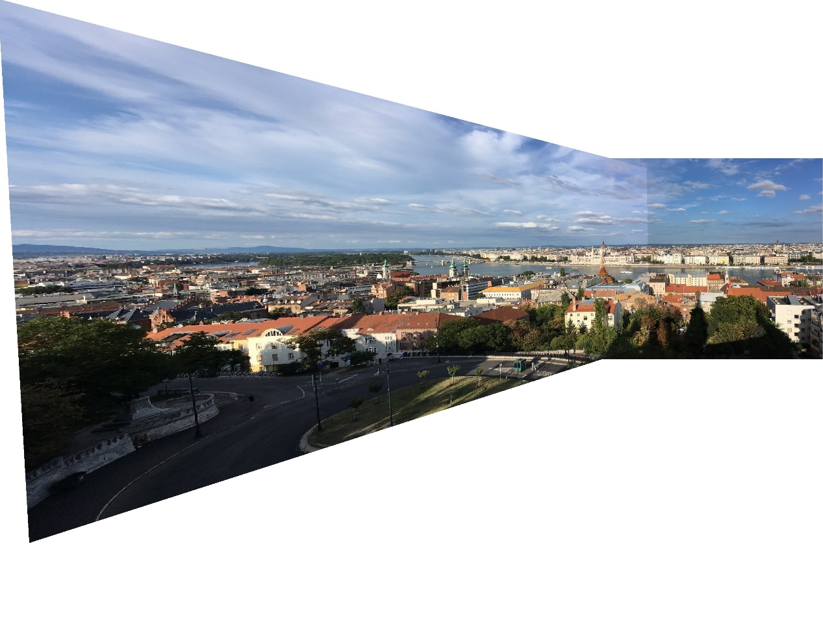

Q2:

1. **The residuals for both unnormalized/normalized method:**

|  |  |  |
| --- | --- | --- |
| method | Residual unnormalized method | Residual normalized method |
| Residual 1 | 0.14912309939434457 | 0.05484509861965783 |
| Residual 2 | 0.17921336681147462 | 0.060334458479578496 |
| Combined | 0.1641682331029096 | 0.057589778549618165 |

Here’s the 3*3 fundamental matrix for both of the methods:

**Fundamental matrix Unnormalized:**

[[ 1.32546895e-06 -1.36852466e-05 6.83862987e-04]

[ 2.88625175e-05 -2.66854091e-07 -4.09703775e-02]

[-5.63235250e-03 3.73349826e-02 1.00000000e+00]]

**Fundamental matrix Normalized:**

[[ 1.86520131e-07 -3.82943867e-06 5.65229482e-04]

[ 2.22767397e-05 2.16768623e-07 -4.11451100e-02]

[-5.30028152e-03 3.69650848e-02 1.00000000e+00]]

**Visualizations:**

Unnormalized on I2:

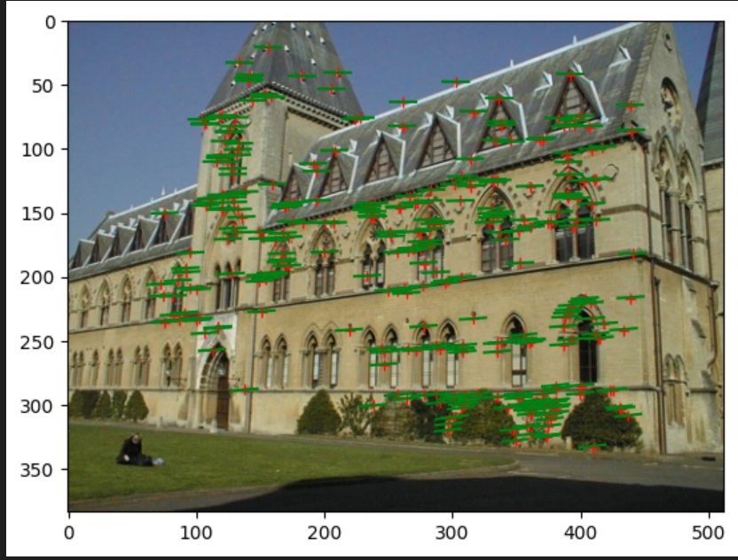

Unnormalized on I1

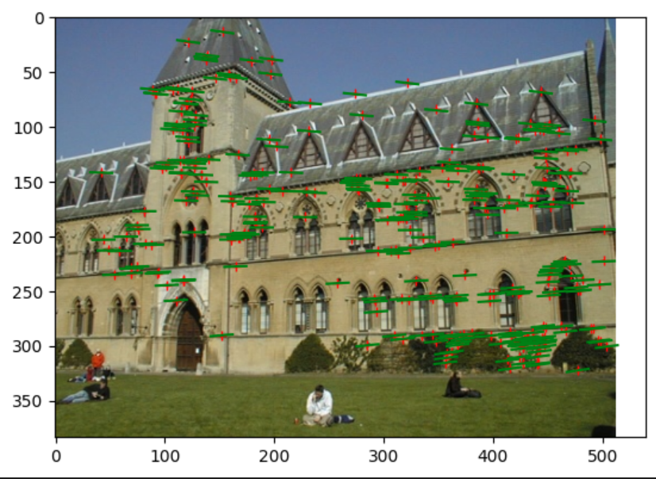

Normalized on I2:

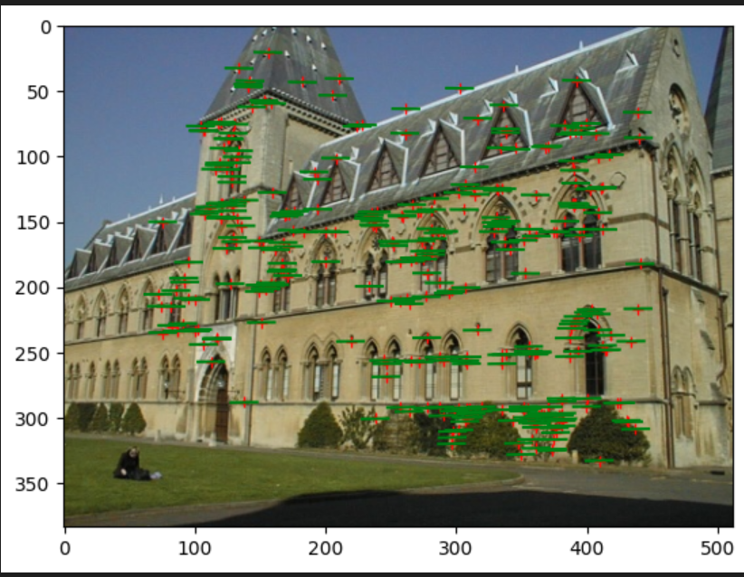

Normalized on I1:

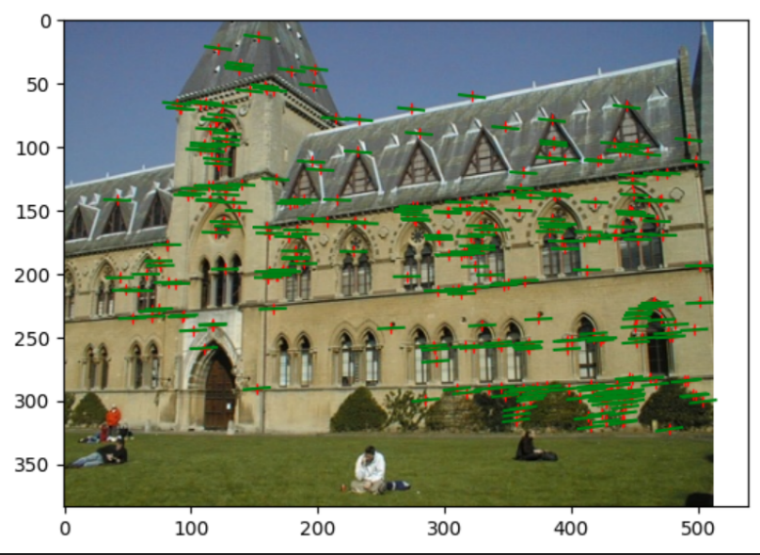

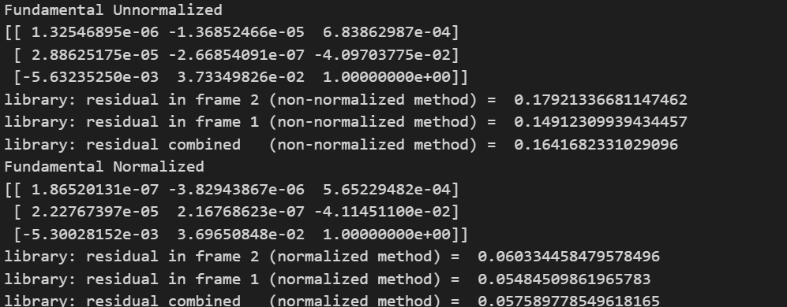

**2.**

lab 1 camera projection

[[-2.33260962e+00 -1.10025080e-01 3.37513233e-01 7.36686567e+02]

[-2.31044166e-01 -4.79515070e-01 2.08722206e+00 1.53627263e+02]

[-1.26377057e-03 -2.06774255e-03 5.14712340e-04 1.00000000e+00]]

lab 2 camera projection

[[ 6.93154686e-03 -4.01684470e-03 -1.32602928e-03 -8.26700554e-01]

[ 1.54768732e-03 1.02452760e-03 -7.27440714e-03 -5.62523256e-01]

[ 7.60946050e-06 3.70953989e-06 -1.90203244e-06 -3.38807712e-03]]

residuals between the observed 2D points and the projected 3D points:

residual in lab1: 13.545832894768449

residual in lab2: 15.544953471723453

**3.**

lab1 camera center [305.83276769 304.20103826 30.13699243]

lab2 camera center [303.10003925 307.18428016 30.42166874]

library1 camera center [ 7.28863053 -21.52118112 17.73503585]

library2 camera center [ 6.89405488 -15.39232716 23.41498687]

**4.**  
Here are the 3D reconstruction errors for both lab pairs and library pairs, also the visualization.  
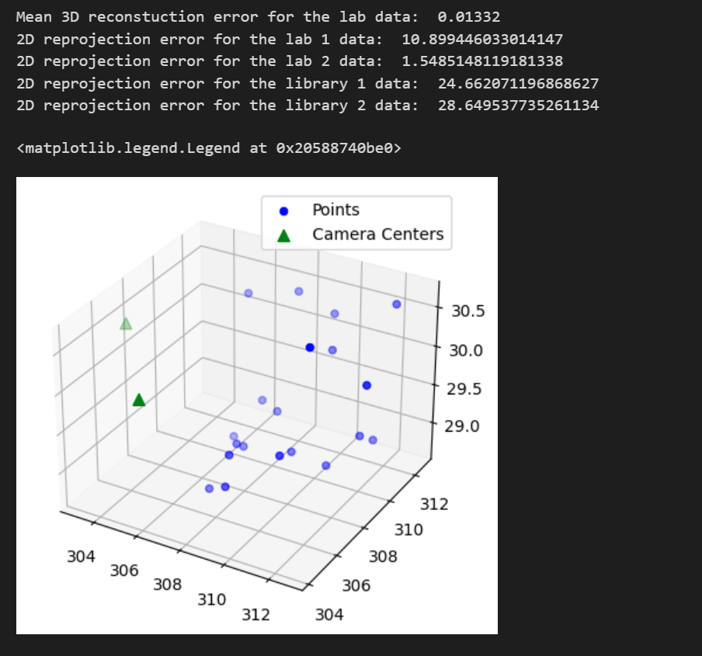

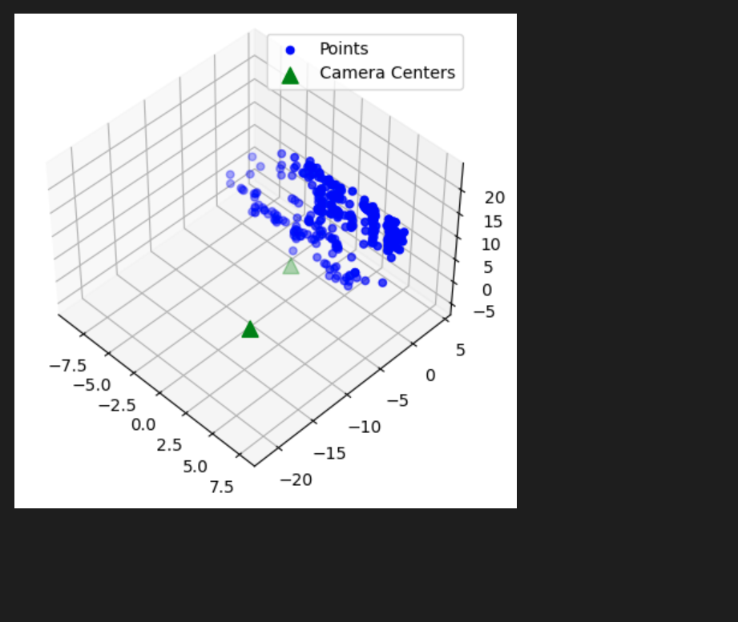

1. **Extra credits**

For the extra credits, I used the ransac to get the fundamental matrix, here’s the results for both image pairs.

**Lab:**  
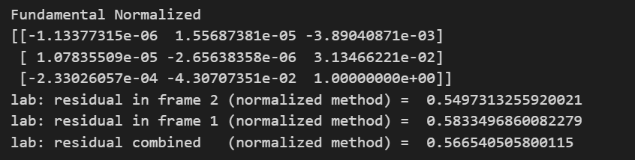

The performance are relatively similar to the results from the ground truth matches. The number of inliers is 18 and the average residual is 0.61.

**Library:**

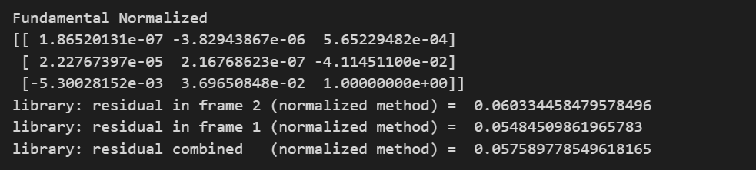

The number of inliers is 7 and the average residual is 0.67.

**Q3:**  
**1.**  
For three parallel lines in total, we have the vanishing points at (-1.91080224e+03, 9.38131166e+01,1), (3.67966328e+03, -1.05848093e+02, 1), (2.17582618e+03, 5.63670907e+03,1)

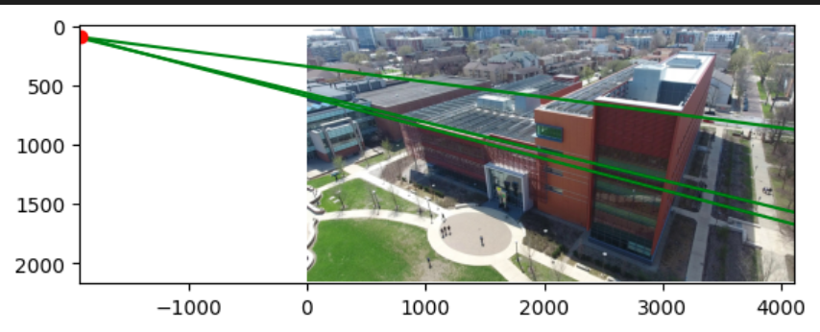

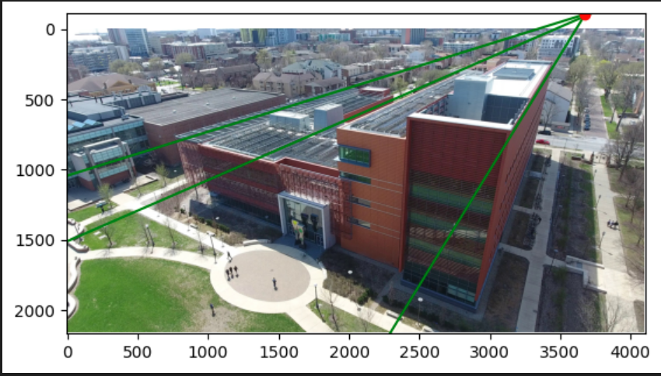

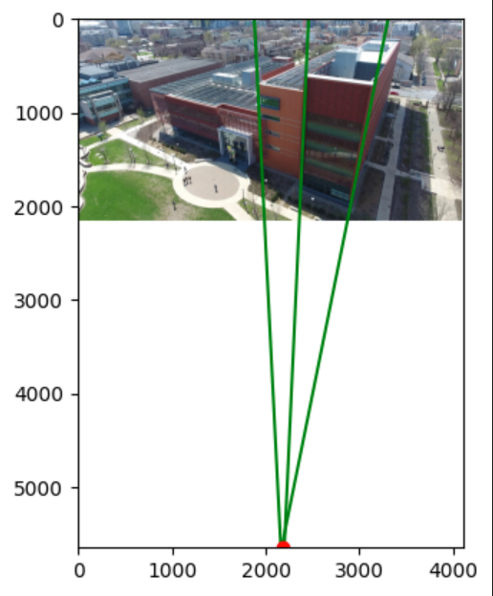

**2.**

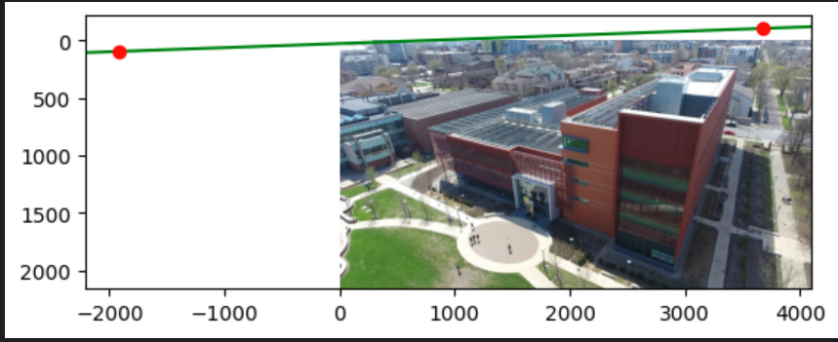  
  
The parameter is a = 0.03569183871611272

b= 0.9993628433402271

c = -25.55329751895859

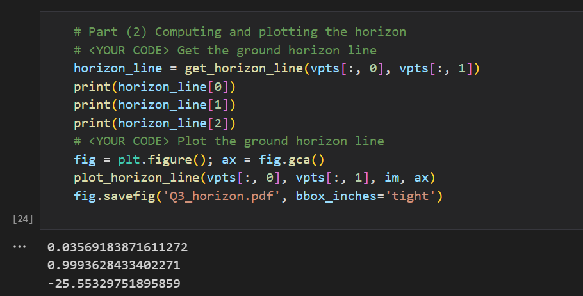

**3.**

The camera parameter is f = 5274144.54223915, optical center (principal point) of the camera is:

[[5.27414454e+06 0.00000000e+00 2.01457715e+03]

[0.00000000e+00 5.27414454e+06 1.12177522e+03]

[0.00000000e+00 0.00000000e+00 1.00000000e+00]]

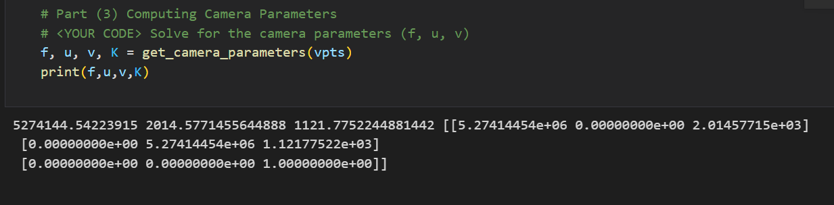

**4.**The rotation matrix of the camera is :  
[[-9.98796950e-01 9.99586526e-01 2.64829340e-10]

[ 4.90372493e-02 -2.87537461e-02 7.41515741e-09]

[ 9.91081853e-11 5.15062867e-11 -1.00000000e+00]]

